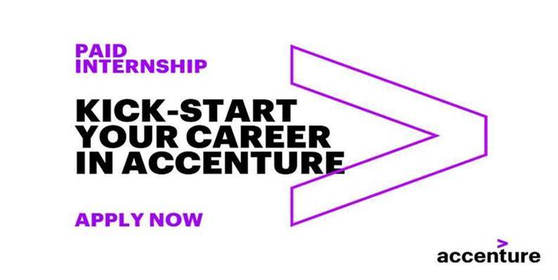

Are you currently an undergraduate or postgraduate student and looking for a challenging internship? Apply now!

**At Accenture, we make every internship a springboard to the future…**

You enter our world of **business, digital, technology and innovation** as one of the team.

You work on real projects in an international environment, directly contributing to delivering results that WOW our clients.

You discover just what you are capable of, personally and professionally, and learn new things you never imagined before.

**WHAT'S IN IT FOR YOU?**

Accenture is an awesome place to work where you keep learning.

By joining us, you'll become part of a global company with a world-class brand and reputation. Besides the work we do for our clients, we're proud of our vibrant, diverse workplace culture: we believe in openness and honesty, fairness and equality, common sense, and realism. We want to get to know the real you and help you explore and grow - whatever it is you're great at. So you will always have lots of learning opportunities (formal and informal) to improve your skills and expertise.

**WHAT DO WE OFFER?**

- Compensation

- Laptop

- Private Medical Insurance

- Interesting projects in a nurturing work environment

- Guidance by a team of experienced consultants

- Possible job opportunities upon successful completion of the internship

**WHO ARE WE LOOKING FOR?**

**Accenture Internships Program** welcomes all ambitious **Bachelors & Masters** students in the field of **Engineering, Software Engineering, Computer and Data Science, Analytics, Statistics or STEM related studies**, with:

-Ability to adapt to quickly changing circumstances and work priorities in a timely manner

-High level of motivation and drive as well as eagerness to learn and explore unknown

-Innovative mindset and able to think out of the box

-Fluency in English

**WHY JOIN ACCENTURE?**

We’re all about “the New,”— new ideas, new technology, new solutions and new talent.

We give young professionals the opportunity to learn how emerging technologies and business process knowledge are applied in real life to create transformative, game-changing solutions for our clients.

Together with talented international colleagues, you will be focusing on connecting the needs of businesses with new possibilities that come with technological progress. Because that's where the real challenges are: inventing and testing things that have never been tried before, getting new applications ready for roll-out, and ultimately guiding our clients to select and apply the right technologies to transform their businesses.

Accenture leverages design thinking, industry insights, and the latest digital methodologies to help our clients innovate, grow, and improve their businesses.

Thanks to our expertise, capabilities, and experience our clients (including some of the biggest brands in the world) trust us to find the right solutions for their needs.

**Interested?**

Are you ready to join Accenture for a career where you can be yourself and do what you love?

**Apply now** by **visiting** [**our career site**](https://www.accenture.com/gr-en/careers/jobdetails?id=00768261_en&title=Paid+Internship+Program)**and uploading your CV** and change the world around you.